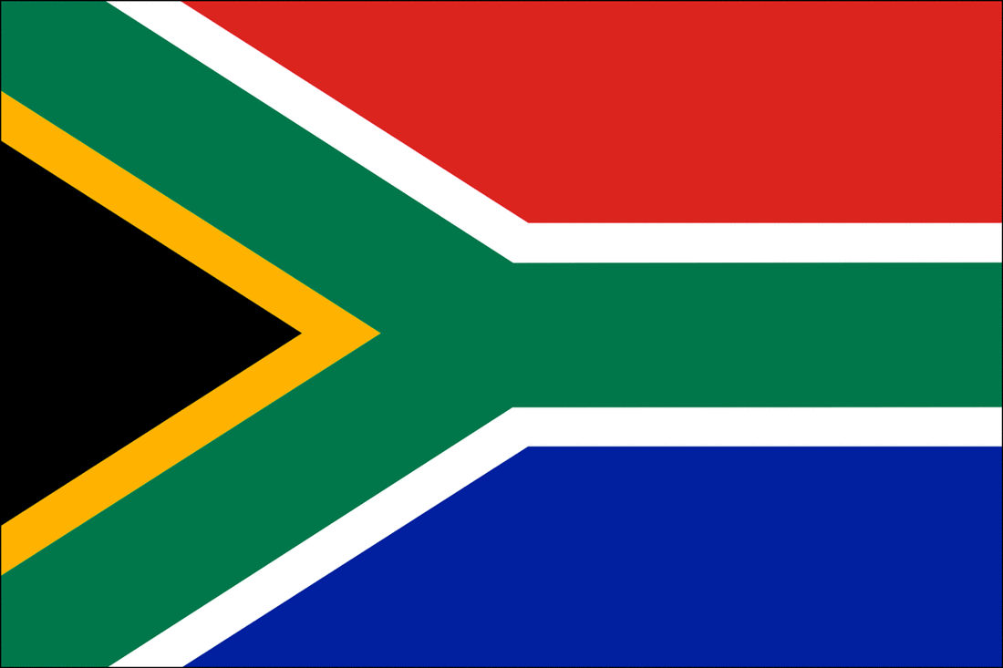Apartheid Background Activity

Comprehension
Watch the video “Apartheid Explained” then note two more important facts that were made:
https://www.youtube.com/watch?v=S7yvnUz2PLE&feature=youtu.be

Ex. Apartheid – the *Afrikanns word for a system of racial segregation;
(*official language of South Africa, created by 17th-century Dutch settlers from Holland.)

1 –

2 –

Terminology
Match the terms in the box with the correct descriptions below.

Word Bank
A. The Natives Land Act 0f 1913
B. 1994
C. …provided framework for Apartheid
D. Town where police opened fire on un-armed protesters
E. The Freedom Charter
F. Separateness; segregated; apart
G. Two teens with opposing views hash out the realities of apartheid
H. “Pass Laws”
I. 1948
J. The act that allowed for “Separate Development”, or racial categories.

3. _______ “Apartheid” meaning
4. _______ This legislation marked the beginning of territorial segregation.
5. _______ The year the National Party gained power in South Africa.
6. _______ Population Registration Act of 1950
7. _______ Required non-whites to carry documents permitting their presence in certain areas
8. _______ Policies that allowed South Africa’s government to legally deny Black-majority…
9. _______ This document stated: “South Africa belongs to all who live in it, Black or White.”
10. _______ The Color of Friendship (movie)
11. _______ The official end of Apartheid
12. _______ Sharpesville
Analysis (Write complete sentences!!!)

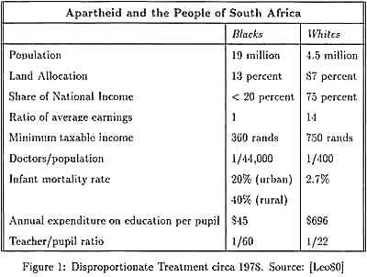

13. PICK ONE of the facts in the diagram above and describe how this statistic tells of the injustice that the black community witnessed during Apartheid:

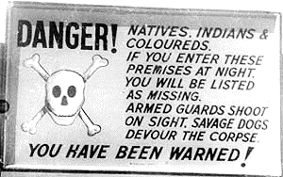
14. List three similarities you see between apartheid in South Africa and the history of segregation in the U.S.? (Which specific events come to mind?)

1-
2-
3-

15. Based on what you now know about apartheid in South Africa, what kind of equality were people fighting for in this country from 1948-1994?) and how did these events relate to our theme of “Finding Common Ground”?

