ESPN’s story continues to reveal layers in lives of Leroy Sutton, Dartanyon Crockett and Lisa Fenn
By George Thomas
Published: July 5, 2013 - 11:00 AM
https://www.ohio.com/akron/news/top-stories-news/espn-s-story-continues-to-reveal-layers-in-lives-of-leroy-sutton-dartanyon-crockett-and-lisa-fenn

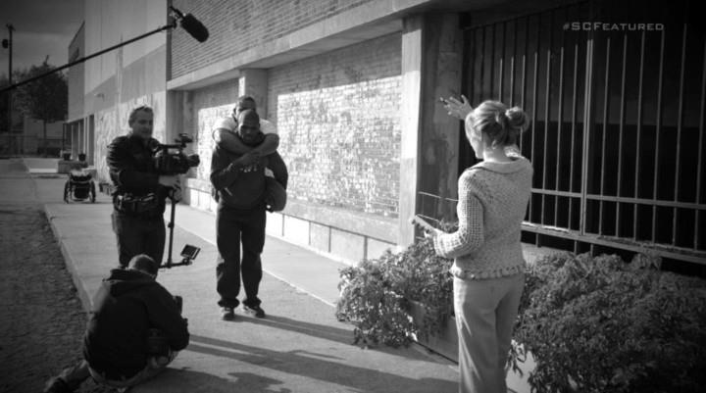 Four years ago Lisa Fenn and ESPN profiled Cleveland high school wrestlers Dartanyon Crockett and Leroy Sutton. Sutton, of Akron, who has no legs, and Crockett, who is legally blind, found strength and friendship through their challenges and both earned diplomas in 2009. The cable network will update their story on the 10 a.m. ET SportsCenter on Sunday, July 7, on ESPN2. Fenn, (right) a Cleveland native who left ESPN in 2010, has maintained contact with both Crockett and Sutton. (ESPN)

The toughest aspect of being a journalist is maintaining the proper distance from the subjects of a story.
Sometimes, chucking aside your humanity and morphing into a version of Star Trek’s emotionless Mr. Spock isn’t possible, nor is it right.
Lisa Fenn, a former producer for ESPN learned that when she told the story of Leroy Sutton, a young man familiar to a lot of Akronites.
The Beacon Journal chronicled Sutton’s tale of being run over by a train and his subsequent rehabilitation. ESPN followed in 2009 with a piece on its newsmagazine Outside the Lines, telling the story of how Sutton and his wrestling teammate, Dartanyon Crockett developed a friendship.
They were teammates on the Lincoln West High School wrestling team in Cleveland. Crockett, legally blind, often carried Sutton, whose legs were amputated after he was run over by a train in 2001 when he was 11 years old living in Akron. The story touched a lot of individuals, but few the way it did Fenn. It shows in a follow-up piece that will air on Outside the Linesat 9 a.m. Sunday and SportsCenter at 10 a.m. on ESPN2.
Giving in
Rather than part company with Sutton and Crockett, Fenn found herself attached to them after the initial piece. How could she not be? She spent six months working on the story. She got to know both teens during that span. She saw how they lived.
When she filmed on Laird Street, she had to go in with a police escort. She received a quick lesson in the absence of hope of those who live in the area from an Akron cop.
“We call this Laird country because once you’re born on Laird Street you never get off,” the officer told Fenn. “You just move from drug house to drug house.”
Sutton, however, thanks to the generosity of viewers who donated money for a college fund for the two, got out. The rest was Fenn, who eventually left ESPN and continues to be close to both young men.
But it wasn’t easy for her to get to that point with them — especially Sutton.
“Me being a realist, I didn’t really talk to Lisa when she first showed up. It took her a couple of months to crack me,” he said during a phone conversation from Arizona where he is attending college for videogame design. “I didn’t think there was going to be any type of friendship or any type of relationship built up in that situation. But now it’s like another mom.”
Fenn said it was absolutely necessary for her to bond with the two because a story about their friendship would only translate to the screen if she were part of it. It affected her more than she thought.
“At some point you can’t expect to stop being human,” she said. “It affected me and I just wanted to stop the suffering. At some point you say enough. I want to do something about this.”
Continuing the story
It wouldn’t be wrong to say that the piece on SportsCenter airing Sunday proves to be a sequel of sorts as ESPN reporter Tom Rinaldi follows up with Fenn, Sutton and Crockett, who continue to overcome obstacles in college.
It finds new layers to their friendship, which now includes Fenn, as they pursue different lives.
Crockett, looking for his next challenge, found his way to studying judo after USA Judo saw the initial story and invited him to Colorado Springs, Colo. He picked up the sport quickly and medaled in the Paralympic Games in London last year.
That he picked the sport up that fast proved mind-boggling, Fenn said.
“Dartanyon knew he had to learn this sport and he turned his fingers into callouses. [He] just dug in and learned it,” she said.
Sutton was in a familiar spot in London.
“During the whole time we were together in high school, he was always on the side of the mat telling me what to do,” Sutton said. “You can’t go to an Olympic sport and not have family support, so I wanted to be there as his family.”
Crockett wasn’t alone in his challenges. Sutton, still in school, became a father and Fenn thought that might derail his future.
“I thought the whole house of cards was going to fall and he was going to go back to living in his grandmother’s basement,” she said. “What I’ve come to realize is that Leroy was hit by a train and nothing will ever be as hard as that. He has a perspective that we can’t possibly have on trials and he got back up from it and he’s going to get back up from any other thing that knocks him down.”
The biggest challenge that comes from raising his daughter is that of any parent — time management, he said.
“My disability is not even a disability to me anymore,” he said. “It may seem like that to everyone else, but I’ve lived with it for 12 years now so I don’t really think of it as a disability.”
Still surprised
Fenn might not be shocked about Sutton’s ability to adapt and overcome, but Sutton, now 23, confesses that she surprised both he and Crockett.
“When I think about it, a producer from ESPN, she has already succeeded in her life and she can do a lot more,” he said. “So to see that she dropped some of the things she was doing just to help us out like that seems unlikely.”
Fenn experienced her own mini shock.
“I think what surprised me most is that they returned the love that I had for them. I never expected anything from them,” she said. “I was very happy to harness the opportunities coming their way and point them in the right direction, organize the details and assumed they would ride off into their new lives and I would just smile from afar.”
For anyone who views the 21-minute segment, one of the longest to air on Outside the Lines and SportsCenter, it’s easy to see that the smiles don’t always come from afar and the affection is more than genuine.

George M. Thomas can be reached at gmthomas@thebeaconjournal.com.

