Name _________________________________________________________________ Block __________

Night – STUDY PACKET
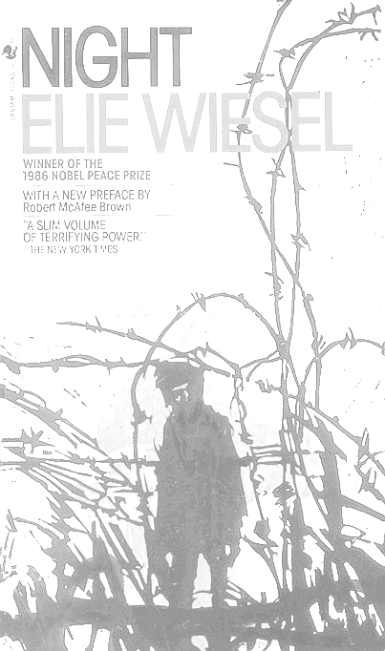

READING SCHEDULE

DAY 1 | Life in Sighet, Transylvania  - Read Section 1 (pgs. 3-22)  - study questions
DAY 2 | Train to Auschwitz  - Read Section 2 (pgs. 23-46)  - begin A-B-C Graffiti, study questions
DAY 3 | Laborers at Buna  - Read Section 3 (pgs. 47-65)  - double-entry journal
DAY 4 | Loss of Faith at Buna  - Read Section 4 (pgs. 66–84)  - continue A-B-C Graffiti, study questions
DAY 5 | The End at Buchenwald  - Read Section 5 (pgs. 85–115)  - finish A-B-C Graffiti, study questions
DAY 6 | Nobel Prize Speech Analysis  - Read Elie’s acceptance speech (pgs. 117–120)  - complete the quiz
DAY 7 | Elie’s Reflection  - Read Preface (pgs. vii-xv)  - study questions
DAY 8 | Study Packet DUE!!!  _________________________________________

Night – LIST OF CHARACTERS

Eliezer - The narrator and author of Night is Elie Wiesel’s 15-year-old self, Eliezer. Night traces Eliezer’s psychological journey, as the Holocaust robs him of his faith in God and exposes him to the deepest inhumanity of which man is capable. He tells his story in a first-person voice, and gives an intimate account of the Holocaust through direct language and feelings. Eliezer’s account is limited in scope but gives a personal perspective through which the reader receives a harrowing description of life under Nazis control. As Eliezer struggles for survival, his most fundamental beliefs—his faith in God, faith in his fellow human beings, and sense of justice in the world—are called into question. He emerges from his experience profoundly changed. Despite many tests of his humanity, Eliezer remains devoted to his father. Through Eliezer, Wiesel intimately conveys his horrible experiences and his transformation as a prisoner during the Holocaust.

Moishé the Beadle - Eliezer’s teacher of Jewish faith, Moishé is a poor Jew who lives in Sighet. Moishé represents a commitment to Judaism, and to Jewish mysticism in particular. As Eliezer’s Kabbala teacher, Moishé talks about the riddles of the universe and God’s centrality to the quest for understanding. He is the first character introduced in Night, and his values resonate throughout the text, even though he disappears early on. He is deported before the rest of the Sighet Jews but escapes and returns to tell the town what the Nazis are doing to the Jews. Tragically, the community takes Moishé for a lunatic or liar.

Shlomo - Even though he is the only character other than Eliezer who is present throughout the memoir, Eliezer’s father is named only once, at the end of Night. Shlomo is respected by the entire Jewish community of Sighet, and by his son as well. He and Eliezer desperately try to remain together throughout their concentration camp ordeal.

Madame Schächter - A Jewish woman from Sighet who is deported in the same cattle car as Eliezer. She is taken for a madwoman when, every night, she screams that she sees furnaces in the distance. She proves to be a prophetess, however, as the trains soon arrive at the crematoria of Auschwitz.

Dr. Josef Mengele - When he arrives at Auschwitz, Eliezer encounters the historically infamous Dr. Mengele. Mengele was the cruel doctor who presided over the selection of arrivals at Auschwitz/Birkenau. Known as the “Angel of Death,” Mengele’s words sentenced countless prisoners to death in the gas chambers. He also directed horrific experiments on human subjects at the camp.

Idek - Eliezer’s Kapo (a prisoner conscripted by the Nazis to police other prisoners) at the electrical equipment warehouse in Buna. Despite the fact that they also faced the cruelty of the Nazis, many Kapos were as cruel to the prisoners as the Germans. During moments of insane rage, Idek beats Eliezer.

French Girl - After a beating, Elie notes “I felt a cool hand wiping the blood from my forehead. It was the French girl. She was smiling her mournful smile as she slipped me a crust of bread. She looked straight into my eyes. I knew she wanted to talk to me but that she was paralyzed with fear. She remained like that for some time, and then her face lit up and she said, in almost perfect German: ‘Bite your lips, little brother… Don't cry. Keep your anger, your hate, for another day, for later. The day will come but not now...’ ” Years later, Elie sees a beautiful woman, in Paris, with dark hair and dreamy eyes that he had seen before. “She spoke, ‘I know what it is: Am I Jewish…? Yes, I am. From an observant family… I had false papers and passed as Aryan. And that was how I was assigned to a forced labor unit. When they deported me to Germany, I eluded being sent to a concentration camp… nobody knew that I spoke German; it would have aroused suspicion. It was imprudent of me to say those few words to you, but I knew that you would not betray me.’ ”

Akiba Drumer - A Jewish Holocaust victim who gradually loses his faith in God as a result of his experiences in the concentration camp.

Juliek - A young musician whom Eliezer meets in Auschwitz. Juliek reappears late in the memoir, when Eliezer hears him playing the violin after the death march to Gleiwitz.
The Holocaust – A-B-C GRAFFITI

- Use websites and videos to study the events surrounding The Holocaust (1939-1945).
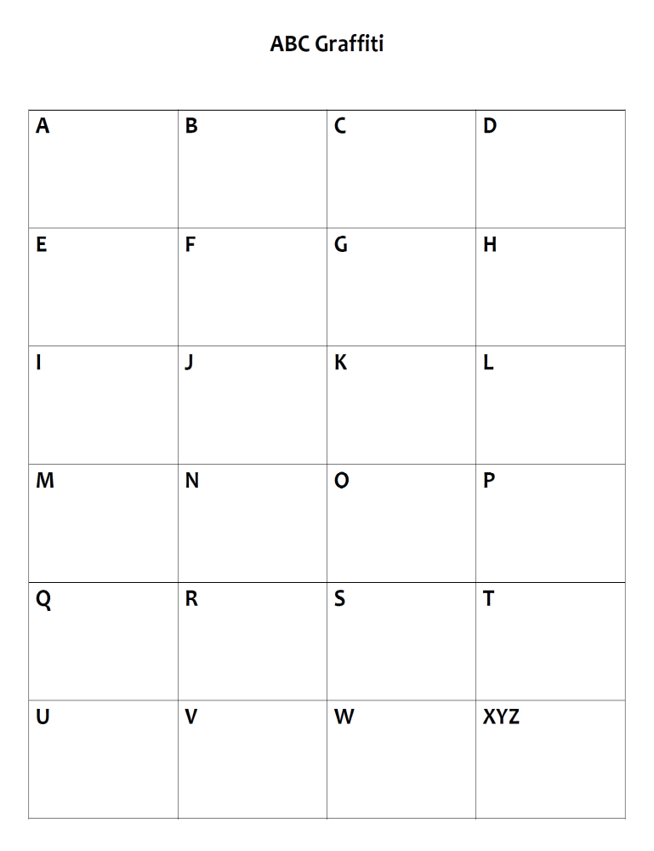
- Write in FIVE items per row (people, places, events, cultural references) to get full credit!!!

Eliezer Wiesel

Sighet Transylvania

Night – STUDY QUESTIONS

Section 1 (pgs. 3-22) - Life in Sighet, Transylvania

Overview - Night begins toward the end of 1941 in Sighet, a small isolated town in Hungary. In introducing the community to the reader, Eliezer, the narrator of the book, focuses on Moishé the Beadle, the man who initiates him into the kabbalah, a form of Jewish mysticism. The story itself begins on the day that all foreign Jews in Sighet are expelled, including Moishé. He and the others are shipped to German-occupied Poland where the Nazis force them to dig their own graves before slaughtering them. Moishé miraculously escapes and returns to Sighet to alert his friends to the danger, but no one believes him. Moishé grows more and more silent as life goes on as usual. By the spring of 1944, the townspeople are hopeful that the war will soon be over. They hear on the radio that Russian troops are advancing farther and farther west. But within days of those broadcasts, German soldiers appear on the streets of Sighet. They order every Jew to wear a yellow star. Soon after, they set up two ghettos in the town. And just a few weeks later, deportations begin—this time all Jews are expelled. Eliezer, his parents, and sisters are among those marched to the railroad station and herded onto cattle cars headed for an unknown destination.

1. How does Eliezer describe Moishé at the beginning of the book? (p. 3)

2. Upon his return, what important news did Moishé try to share with his people? (pgs. 6-7)

3. Name THREE changes to Sighet after the Germans arrive: (pgs. 9-11)

4. Who were “our first oppressors” and how did they treat Eliezer’s people? (p. 19)

5. Describe the mode of transportation the village was forced to use at the end of this section. (p. 22)

Section 2 (pgs. 23-46) - Train to Auschwitz

Overview – Eliezer’s family are crammed into a cattle car on their way to an unknown destination. As night falls, Madame Schächter, a woman Eliezer knew well, screams “Fire!” Her cries disturb the frightened families huddled in the car, but no one else sees the blaze. After people, including her own son, are unable to reassure her, they beg her to remain silent. When the train finally pulls into a station, the first thing people notice is fire. Flames are gushing out of huge chimneys against the black sky. The Jews of Sighet have arrived at Birkenau, a reception center for Auschwitz. An SS officer orders: “Men to the left! Women to the right!” Eliezer and his father are immediately separated from his mother and sisters. As they are marched away from the station, the “veteran” prisoners are angry and amazed to discover that the newcomers have never heard of Auschwitz. Eliezer and his father are stripped of their belongings, their hair, even their names. They are pushed from place to place, beaten, and humiliated without explanation. Eventually they are taken from Birkenau to Auschwitz where an officer tells them that they must work or go to the crematorium. A Polish prisoner quietly advises them to “help one another to survive.” Three weeks later, they are moved to another part of the Auschwitz complex—a slave labor camp called “Buna.”

6. Why do you think the Germans take away the inmates’ personal belongings and clothing? (p. 24)

7. What was foreshadowed by Madame Schächter’s nightmare on the train? (p. 24)

8. What did some of the passengers do to keep Madame Schächter quiet? (p. 26)

9. When Eliezer tells the reader, “Eight words spoken quietly, indifferently, without emotion.
Eight simple, short words.” What were the words and why is Eliezer unable to forget them? (p. 29)

10. Why does Eliezer lie about his age and occupation to the S.S. Officer? (p. 30)

11. Wiesel, in recounting the first night in the concentration camp says, “Never shall I forget that night, the first night in the camp that has turned my life into one long night…” (p. 34). Why does he say this?

12. When Eliezer’s father is beaten, how does it affect him---what does he fear afterward? (p. 39)

Section 3 (pgs. 47-65) - Laborers at Buna

Overview - At Buna, Eliezer and his father endure routine humiliations and random violence. At one point, a Kapo’s assistant tries to take Eliezer’s shoes. Sometime later, a Kapo demands the gold crown on his tooth. On yet another occasion, Eliezer is beaten for no reason at all. At the same time, his father is finding it harder and harder to keep up. Eliezer is torn between anger at him for not knowing how to march and his love for the man. More and more, Eliezer feels he is becoming a “starved stomach.” Although a public hanging troubles him briefly, he and the other men are too hungry to think much beyond their dinner. Then a child and two adult prisoners are hanged for hiding weapons. Watching the boy slowly die, a prisoner asks, “For God's sake, where is God?” Eliezer, deeply moved by the hanging, hears a voice answer, “Where He is? This is where–-hanging here from this gallows.” (pg. 65)

Double-entry journal

I read…  (write a quote, an action or summary of an event) | I think…  (write your reaction to this event or quote)
13.

14.

15.

16. List TWO things the French woman does for Elie that represents hope/humanity at Buna. (p. 53)

17. Describe the scene with the soup cauldrons. (p. 58-60)

18. During one hanging, Elie and the others cried. What made this one different from others? (p.63-64)

Section 4 (pgs. 66-84) - Loss of Faith at Buna

Overview - On the eve of Rosh Hashanah (Jewish New Year), Eliezer attends services even though he has begun to question God. After the service, he and his father share a rare moment of understanding. Yet seconds later, the moment is gone. He looks into his father’s face and sees “Nothing. Not the shadow of an expression. Defeat.” But a few days later, he, his father, and the others in the camp hotly debate whether to fast on Yom Kippur, the holiest day in the Jewish year—the Day of Atonement. Not long after, another “selection” is announced and this time Eliezer’s father is chosen. Preparing for the end, he gives his son his inheritance—a knife and a spoon. Eliezer spends the entire day fearing his father has been taken away. However, when he returns that night, his father is still there. He somehow made it through the final “selection.” By January, Eliezer is in the camp hospital with an infected foot. While he is there, the prisoners learn that the camp will soon be evacuated. For the first time in months, Eliezer and his father have a choice: they can leave with others or stay behind. They leave marching with the other prisoners through the icy countryside in the dead of winter to yet another unknown camp.

19. Why didn’t Elie fast on Yom Kippur?

20. What advice was Elie given to pass the selection process?

21. Why was Elie placed in the hospital?

22. What does Elie learn later about the fate of those who stayed behind in the camp hospital?

Section 5 (pgs. 85-115) - The End at Buchenwald

Overview - After leaving Buna, Eliezer, his father, and the other prisoners march forty-two miles through the ice and snow to Gleiwitz. When the survivors reach their destination, they are packed into darkened barracks. Unable to sleep, Eliezer spends the night listening to the sound of a violin playing to an audience of dead and dying men. The violinist is Juliek, a fellow prisoner from Buna. The next morning, he too is dead. Three days later, the prisoners, still without food or drink, face yet another “selection”--once again, Eliezer’s father is “selected.” When Eliezer rushes to his side, he causes such confusion that the two end up on the train to yet another camp. Conditions on this transport are so horrific that the SS order the living to throw the dead from the train. By now it has been ten days since the starved men have eaten. When the train finally reaches Buchenwald, a concentration camp, only twelve prisoners in Eliezer’s car are still alive. Among them is Eliezer’s father, although very weak. Stricken with dysentery, he can no longer take care of himself. Eliezer desperately tries to protect him even though a fellow prisoner advises, “In this place, there is no such thing as father, brother, friend. Each of us lives and dies alone.” The next day Eliezer’s father is dead. Eliezer is unable to cry and even admits that in “the recesses of his weakened conscience” he now feels free. Three months later, as the war is drawing to a close, the Germans decide to evacuate the camp and kill off the remaining prisoners. Before they can act, the camp resistance movement drives the Germans out of Buchenwald. That evening the Americans arrive. The book ends with Eliezer in the hospital, a victim of food poisoning. After hovering between life and death for two weeks, he looks into a mirror, the first he has seen in a year. A corpse gazes back at him.

23. What was Juliek’s last act?

24. How did Elie help his father when the selection was made?

25. What did the prisoners do when they were freed?

Nobel Prize Speech Analysis (pgs. 117–120)

26. In his greeting (p. 117), Wiesel states that humankind’s most “urgent and noble aspiration” is what?
a. oppression b. revenge c. peace d. forgiveness

27. In paragraph 4, the young Eliezer discovers the “Kingdom of Night.” What does this symbolize?
a. the Holocaust b. Sighet, Transylvania c. the Nazi government d. the Jewish people

28. Which of the following images does Wiesel NOT use to evoke the horror of the Holocaust?
a. ghettos b. cattle cars c. deportations d. gas chambers

29. In paragraph 5, when he says, “This is the twentieth century, not the Middle Ages,” he means…
a. …such horrors could only occur in the past.
b. ...the Nazis were friends of the Jews.
c. …they should not be forced to endure such atrocities.
d. …the allied forces would have rescued them.

30. When he says, “what have you done with my future, what have you done with your life?” he hopes…
a. Wiesel has become a businessman. c. Wiesel has shared the story of this tragedy.
b. Wiesel has found his family members. d. Wiesel got revenge on those who were guilty.

31. According to Wiesel’s speech, why is it important “never to be silent”?
a. Neutrality helps the oppressor. c. Borders are irrelevant—sometimes we must interfere.
b. Silence encourages the tormentor. d. all of the above

32. “There is so much injustice and suffering crying out for our attention: victims of…” Which of these does he mention in his speech?
a. hunger b. racism c. persecution d. all of the above

33. What did Elie Wiesel say was the “most insidious danger of all”?
a. oppression b. indifference c. persecution d. anger

34. Wiesel mentions that these men, “Raoul Wallenberg, an Albert Schweitzer, a Martin Luther King Jr.” represent how one person of _____________ can make a difference.
a. integrity b. stupidity c. arrogance d. none of the above

35. Which of the following words best describes the tone of Wiesel's speech?
a. vindictive b. melodramatic c. inspirational d. confrontational

Elie’s Reflection - Preface (pgs. vii-xv)

36. List one reason why Elie suggests that he wrote this book? (p. vii)

37. Describe what he meant when he says that the “Jews were killed twice?” (p. viii)

38. Why did Elie feel like he needed to invent a “new language” in order to adequately tell his story? (p. ix)

39. How was Night originally received by the public? How did Jews feel about it? (p. xiv)

40. What does Elie believe is his “responsibility?” (p. xv)

Night - Journey Map
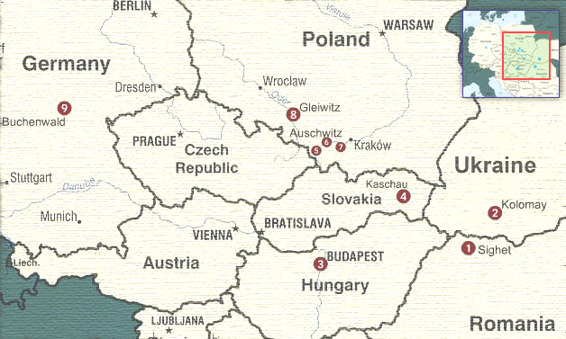

1) Sighet: Eliezer Wiesel was born in Sighet, Transylvania (modern-day Romania) in 1928. In 1944, the German Gestapo and the Hungarian police force Sighet’s Jewish citizens into ghettos. Then, they deport them by train—80 persons to every cattle car.

2) Kolomay: The Hungarian police expel Moishe the Beadle and the other foreign Jews from Sighet. The Gestapo takes control of the train once it reaches Polish territory (now part of Ukraine) and executes the Jews in the Galician forests near Kolomay (Kolomyja).

3) Budapest: In 1944, German troops enter Hungary with the newly elected government’s approval. Stories of anti-Semitism in Budapest reach Sighet, but the Jewish citizens still think they are safe.

4) Kaschau: Two days after leaving Sighet, the train stops in Kashau near the Czechoslovakian border (Kosice in modern-day Slovakia). The German Army takes control of the train.

5) Birkenau: Seconds after stepping off the train, Eliezer and his father are separated from his mother and sisters forever. Part of the Auschwitz complex, Birkenau was built after the 1942 Wannsee Conference in Berlin and quickly became the Nazi’s largest killing center. It is estimated that 1.1 million Jews, 75,000 Poles, 21,000 Gypsies and 15,000 Soviet prisoners of war perished in its flames.

6) Auschwitz: Eliezer and his father are introduced to the motto Arbeit Macht Frei (“Work Makes You Free”) at Auschwitz. As the Soveit Army advances in the fall of 1944, the Nazis evacuate the Auschwitz complex sending the prisoners on foot and by cattle car to other camps. The Soviet Army liberates the few who remain in January 1945.

7) Buna: Also known as Auschwitz III, Buna is a smaller work camp about a four-hour walk west of Auschwitz. Eliezer and his father are sent to Buna to work in a warehouse sorting electrical parts.

8) Gleiwitz: In January, Eliezer and his father are evacuated from Auschwitz and forced on a two-night death march to Gleiwitz (Gliwice). They run more than 20 kilometers (about 13 miles) through the snow before stopping. After three days in Gleiwitz, a transport train for Buchenwald arrives—this time each cattle car carries 100 Jews.

9) Buchenwald: For three days and nights, Eliezer and the other prisoners ride the train from Gleiwitz (Gliwice) in Poland to Buchenwald (near Weimar) in Germany with no food or water. Only 12 of the 100 men in Eliezer’s car survive. Eliezer and about 20,000 prisoners are liberated on April 11, 1945.

