Grammar Station - Subjects, Predicates & Objects

REVIEW:
Subject is the noun in the sentence or clause that takes action.
Predicates are actions (verbs) in the clause or sentence.
Objects are nouns in the sentence or clause that take on the actions.

For each of the following sentences, answer the accompanying questions.

1. The pirate captain sang an old pirate song on his ship.

Subject: Who sang? _____________________
Predicate: What’s the action? _____________________
Object: What nouns receive the action? _____________________

2. Singing was his favorite activity.

Subject: Who sang? _____________________
Predicate: What’s the action? _____________________
Object: What nouns receive the action? _____________________

3. He also liked feeding his parrot, swashbuckling and pillaging.

Subject: Who sang? _____________________
Predicate: What’s the action? _____________________
Object: What nouns receive the action? _____________________

Write 3 sentences of your own, then do the following:
Underline the Subjects, circle the Predicates and double underline Objects.

1

2

3

Grammar Station - Prepositional Phrases

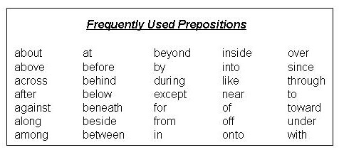

Circle the best preposition to finish the following sentences.
My brother fell asleep (over, under, in) the tree.
The bird slept (with, off, in) the tree.
Judy held the sign (to, above, in) her head.
Jamaal went (under, to, with) the beach.
Miles ran (of, to, out) the finish line.

Using the list of prepositions, write 3 sentences using a preposition. Be sure to circle the prepositions in your sentences.

1

2

3

