For each of the following ideas, draw what represents this idea to you. Underneath each drawing, explain your reasoning with 2-3 sentences.

Freedom

Drawing explained:

Fear

Drawing explained:

- The Cat from “Once Upon a Time”
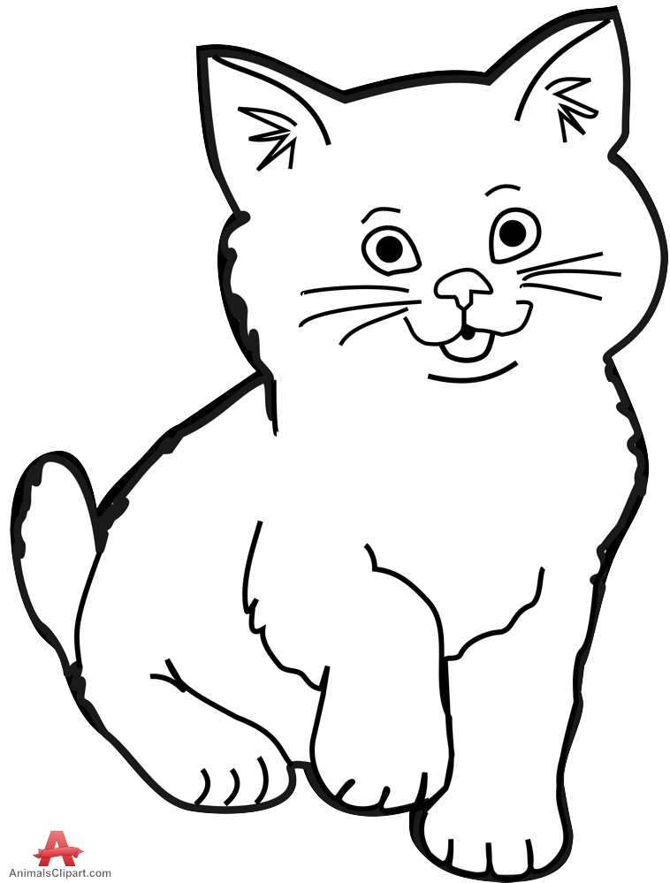
- The Boy from “Once Upon a Time”
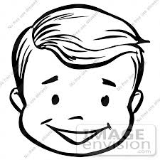
- The Fence from “Once Upon a Time”
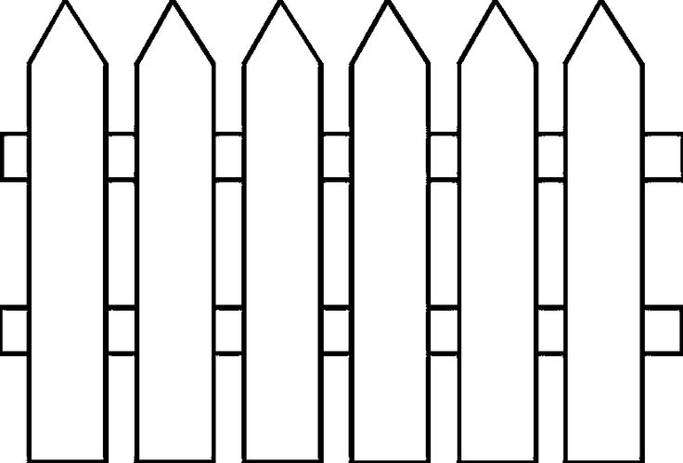
- The Mother-in-Law/Witch from “Once Upon a Time”
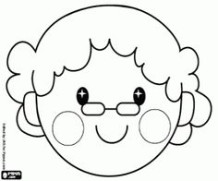
- The Quilt from “Quilt of a Country”
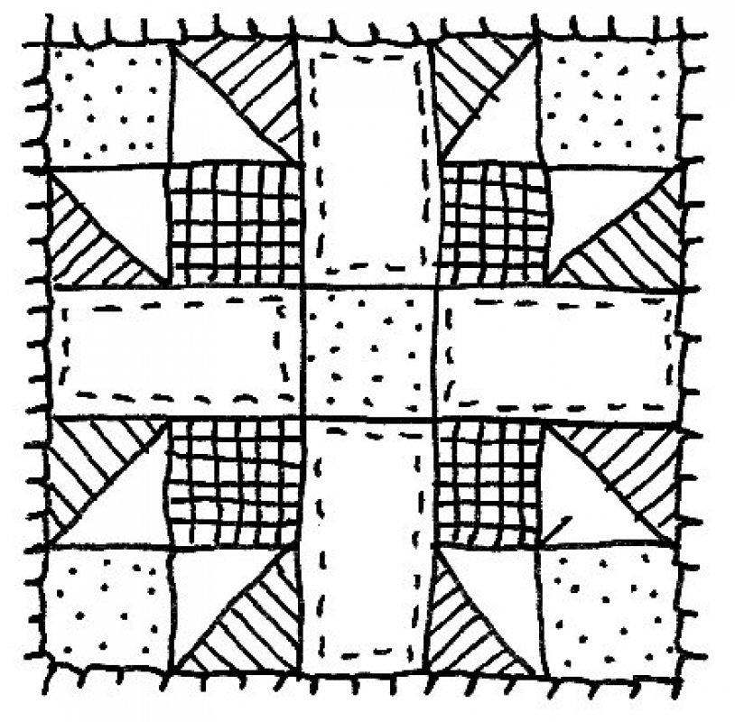
- The Thread from “Quilt of a Country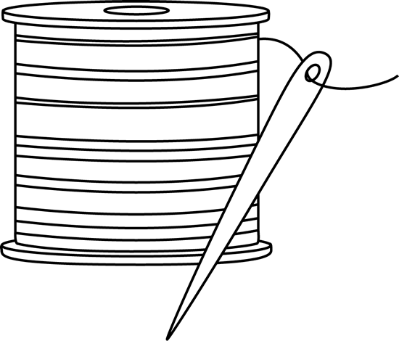”

- America

- Freedom

- Fear

- Patriotism

- The Government

- Innocence

