TERMS STATION

Word Bank
Symbolism, conundrum, claim, pluralistic, intention, theme, discordant, opposing claim, counterclaim, audacious, paraphrase, fairytale, apartheid, epicenter, intrusion

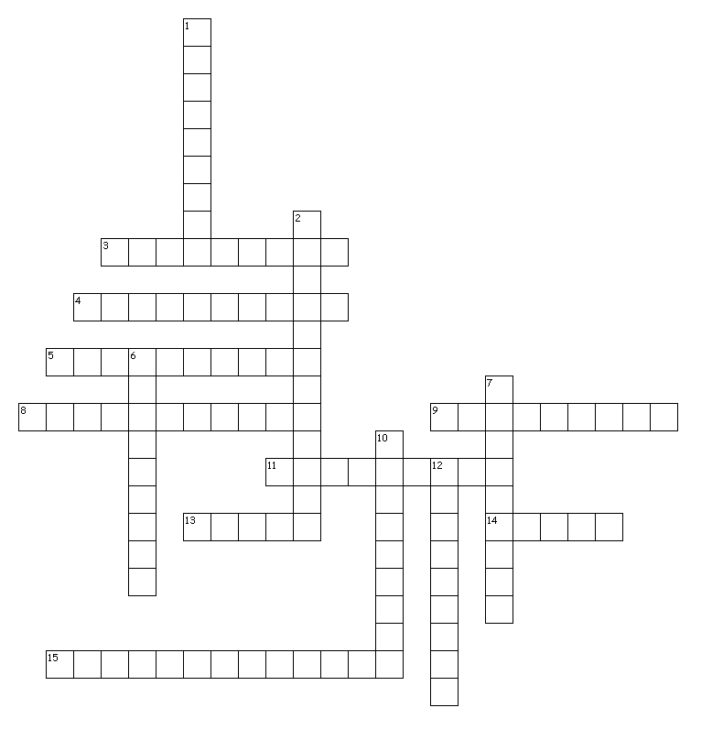

ACROSS
3. act of trespass or invasion
4. conflicting or not harmonious
5. express the meaning of the writer or speaker using different words
8. consisting of many ethnic or cultural groups
9. a riddle or puzzle
11. literary structure that employs the use of magical settings and characters
13. a writer's position on a problem or issue
14. central idea of a text or story
15. a stance from a different viewpoint
DOWN
1. the focal point
2. support for a claim based on an opposing idea
6. government policy of racial segregation and discrimination
7. purpose or plan
10. symbolic meaning attributed to natural objects or facts
12. bold or rebellious

